PENNSYLVANIA
PUBLIC UTILITY COMMISSION
Harrisburg, PA 17120

Public Meeting held February 24, 2022
Commissioners Present:

Gladys Brown Dutrieuille, Chairman
John F. Coleman, Jr., Vice Chairman
Ralph V. Yanora
Petition of Duquesne Light Company for Approval to Modify its Supplier Master Agreement | Docket Number:  P-2022-3030423
ORDER
BY THE COMMISSION:

On January 12, 2022, Duquesne Light Company (Duquesne Light), Utility Code 110150, filed a Petition for Approval to Modify its Default Service Plan (DSP) IX Supplier Master Agreement (SMA) to implement a Capacity Proxy Price (CPP) (Petition) for its upcoming default service auction in March 2022.

Duquesne Light served the Petition on the Pennsylvania Public Utility Commission’s (Commission) Bureau of Investigation and Enforcement, the Office of Consumer Advocate, the Office of Small Business Advocate, CAUSE-PA, Calpine Retail Holdings, LLC, Todd S. Stewart, representing Nextera Energy Power Marketing, ChargePoint, StateWise Energy PA LLC & SFE Energy, MAREC Action, and the National Resources Defense Council. No answers or comments were filed, and no hearings were held. For the reasons expressed in this Order, the Commission will grant the Petition as approved by this Order.

Duquesne Light states it is requesting approval to modify its SMA by implementing a CPP. The proposed modification will include a CPP for the PJM Interconnection, Inc. (PJM) 2023/2024 delivery year, as part of Duquesne Light’s upcoming March 2022 default service auction. Duquesne Light states that on December 22, 2021, the Federal Energy Regulatory Commission (FERC) entered an Order directing a further delay in the PJM Base Residual Auction (BRA) for capacity for the 2023/2024 delivery period. Duquesne Light submitted an informational filing on January 31,2022, indicating that PJM had set a new proposed date of June 2022 for its BRA. Therefore, for the same reasons that Duquesne Light implemented a CPP for its March and September 2021 default supply procurements, it seeks by this Petition to implement another CPP for use in its upcoming March 2022 procurement. Petition §I, p. 2.

Duquesne Light states that its current default service plan, DSP IX, extends through May 31, 2025, and that it procures default supply for Residential and Small Commercial and Industrial customers through a combination of laddered 12-and 24-month fixed price full requirements (FPFR) supply contracts. Duquesne Light conducts Requests for Proposals (RFPs) for these FPFR supply contracts in September and March of each year, for FPFR supply contracts to commence the following December 1 and June 1, respectively. Duquesne Light also states that typically the price of capacity for the full duration of the FPFR contract is known at the time of each RFP. Petition ¶5.

Duquesne Light states that its proposed CPP is calculated as a straight average of the actual capacity prices from the two preceding delivery periods. Duquesne Light also states that it will implement the CPP since the 2023/2024 BRA results will not be released until June 2022, and that the proposed change would only apply to its scheduled March 2022 RFP for Residential and Small C&I default supply. Duquesne Light states that the CPP would not apply to any subsequent RFPs or RFPs for default supply for other customer classes. Duquesne Light further states that it would reconcile the difference between its CPP and the actual price of capacity in the same method as the company’s prior approved CPPs. Petition ¶¶25-27 and Exhibit A.

Duquesne Light states that the structure of its CPP proposal is substantially identical to its prior CPP implementations. Duquesne Light states it is proposing to add an Appendix (Agreement and disclosure of the dollar value of the CPP) to its SMA and limited changes to the bidding rules. Duquesne Light proposes to pay winning wholesale suppliers of 24-month FPFR contracts procured in March 2022 the auction closing price, subject to subsequent true-up for the portion of the contracts that extend into the 2023/2024 delivery period. Duquesne Light also states that once the PJM capacity price is set, the suppliers will be debited or credited, as applicable, for any differences between the CPP and the PJM capacity price. Duquesne Light states that it would then refund or recoup this amount through its next Section 1307(e), 66 Pa.C.S. §1307(e), reconciliation of default supply rates, which would be reflected in its default supply rates effective December 1, 2022, and that the impact of the CPP on customers will be neutral. Petition ¶29.

Duquesne Light avers that an unpriced capacity period injects an element of uncertainty into its default service auctions, which could impair auction liquidity and drive-up default supply prices. Duquesne Light states, as it did in its previous CPP implementation, that a CPP is the appropriate method to mitigate these risks and advance its “least cost over time” and “prudent mix” obligations with respect to the remaining DSP IX term. Duquesne Light also states that as discussed in its previous CPP implementation, the CPP is impact-neutral to customers and is consistent with past approaches taken by Duquesne Light, other Pennsylvania EDCs, and neighboring states. Duquesne Light further states that it implemented its March and September 2021 CPPs without incident, and that the solicitations demonstrated to Duquesne Light that the CPP is understood by wholesale suppliers and supports a competitive procurement. Petition ¶¶28-30.

We agree with Duquesne Light’s proposal to modify its Supplier Master Agreement to include a capacity proxy price for its upcoming default service auction in March 2022. We find this modification will maintain the diversity of Duquesne’s Light’s default service contracts while mitigating this unpriced capacity period. Accordingly, we grant Duquesne Light’s request to modify its Supplier Master Agreement; THEREFORE,

IT IS ORDERED:

- That the Petition filed by Duquesne Light Company, for approval to modify its Supplier Master Agreement to implement a Capacity Proxy Price for Duquesne Light Company’s upcoming default service auction in March 2022, is hereby granted.

2. That Duquesne Light Company is directed to file a compliance tariff supplement as necessary, on at least one-days' notice, to update the terms of the Default Service Plan in the company's tariff.

3. That the proceeding at Docket No. P-2022-3030423 be closed upon the filing of the compliance tariff.

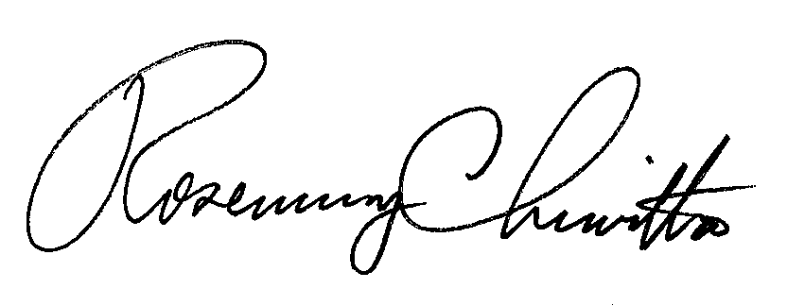
BY THE COMMISSION,

Rosemary Chiavetta
Secretary

ORDER ADOPTED: February 24, 2022
ORDER ENTERED: February 24, 2022

Approved at Docket Nos: P-2020-30230214243149 and P-2021-3027796

